1. **USER’S CORNER**

ADD DATA

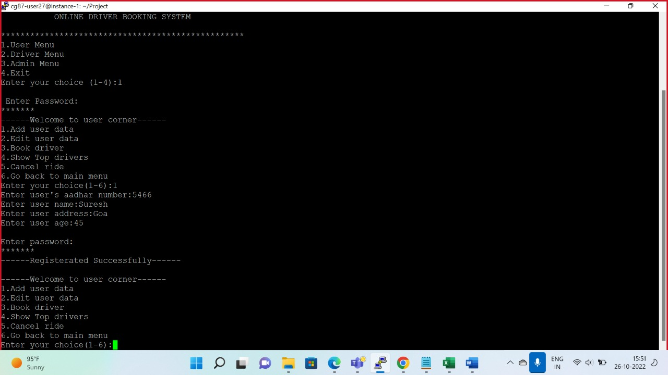

EDIT DATA

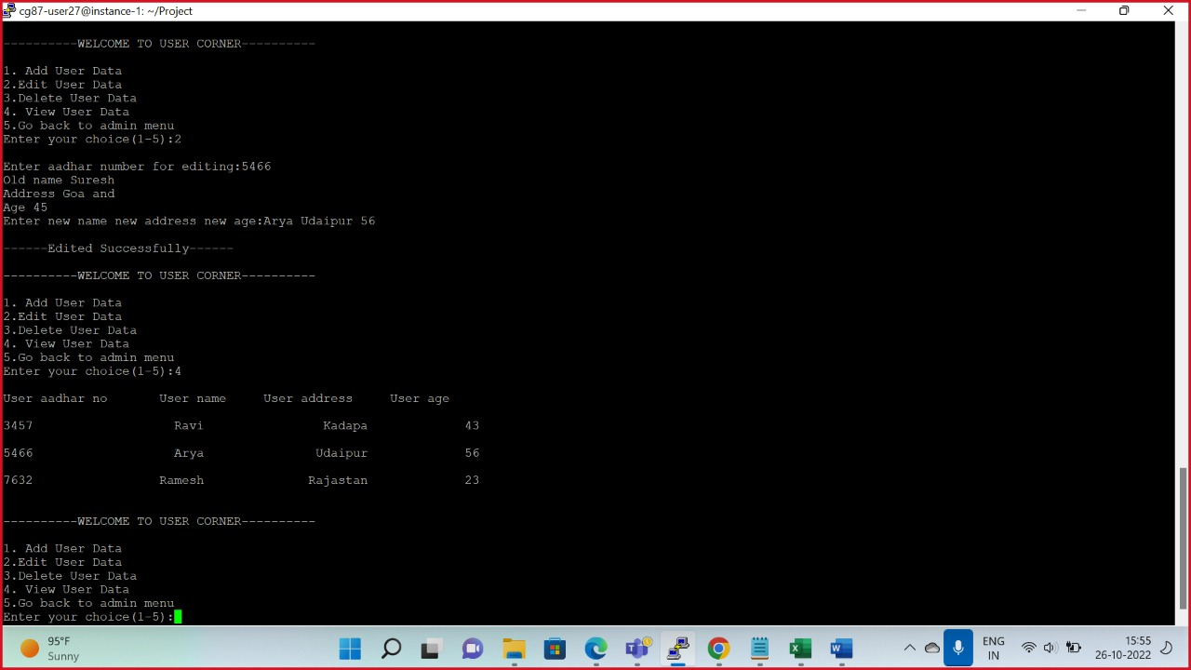

BOOK A DRIVER

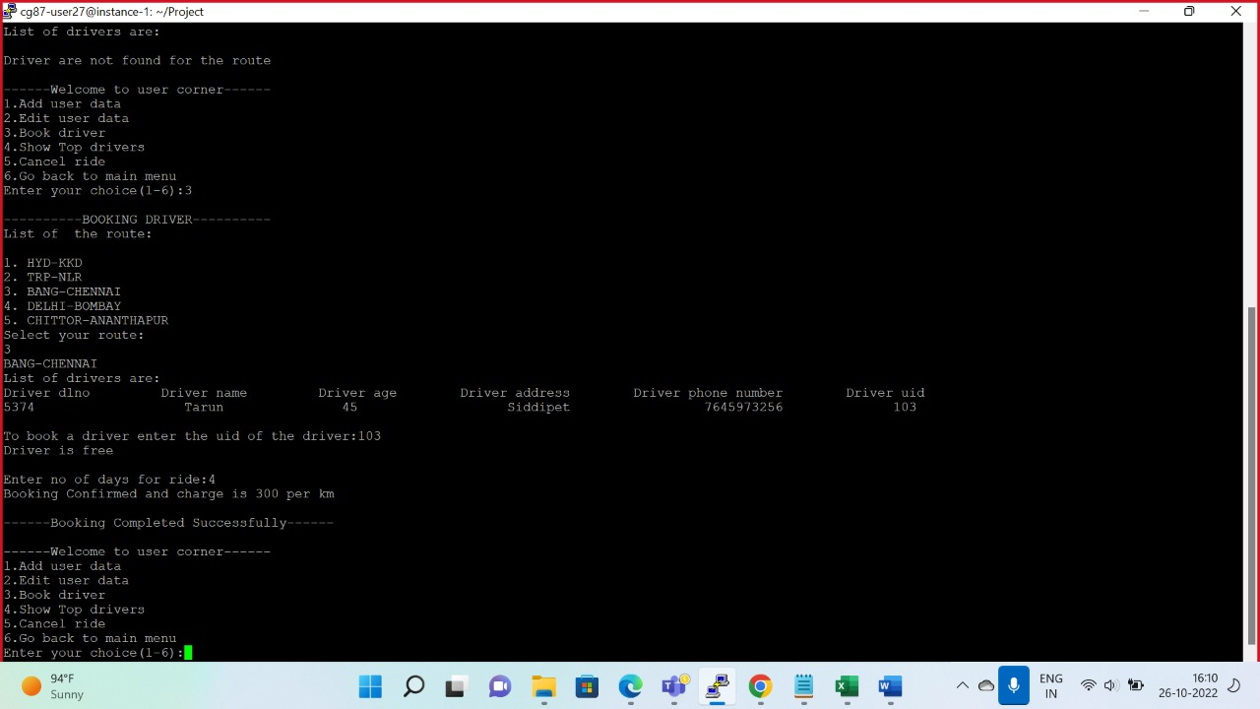

SHOW TOP DRIVER

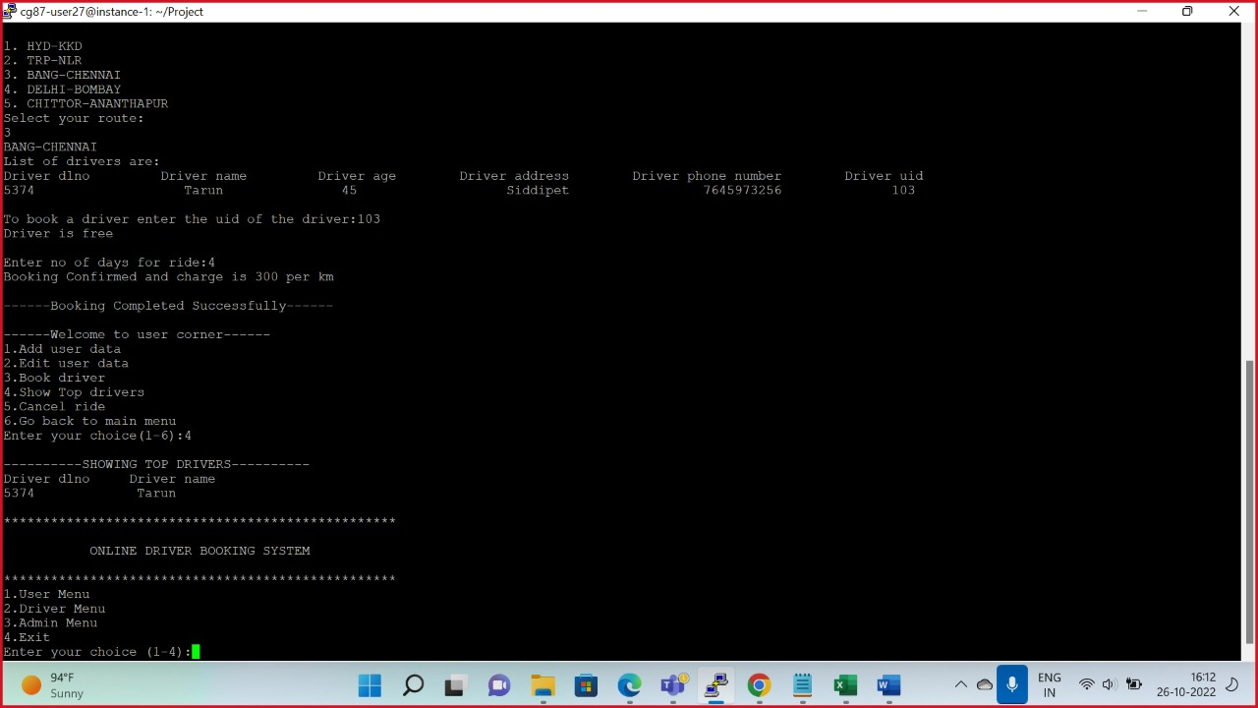

CANCEL THE RIDE

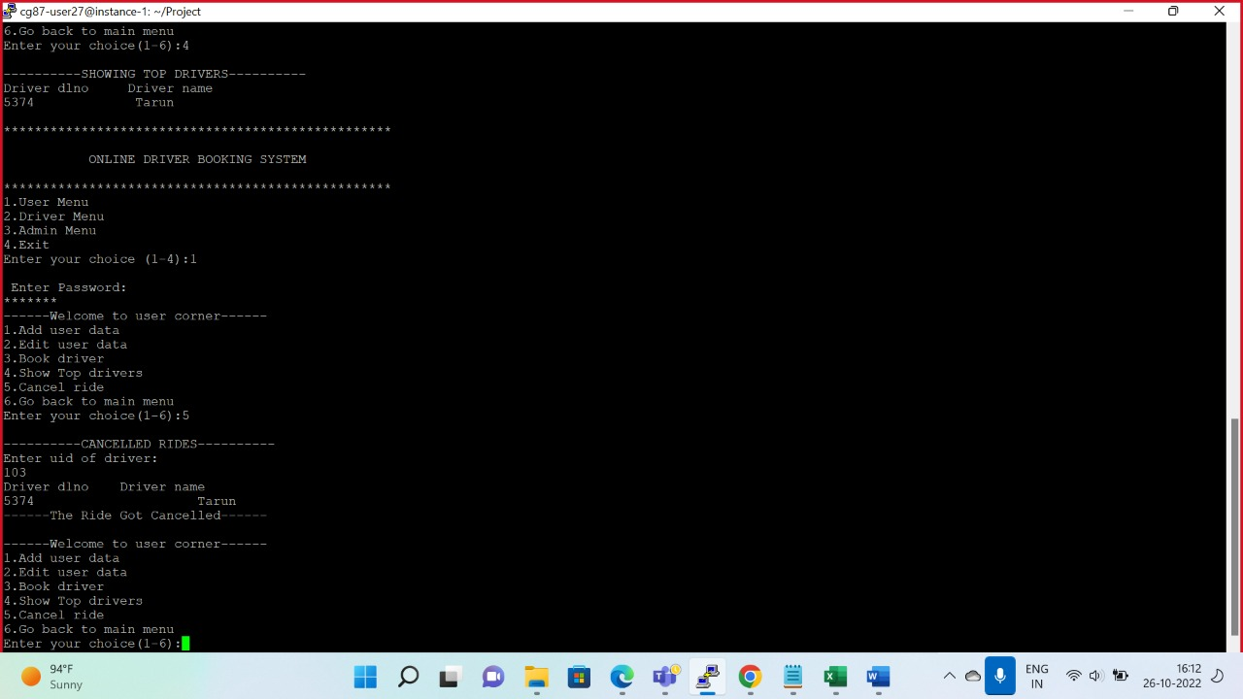

DELETE DATA

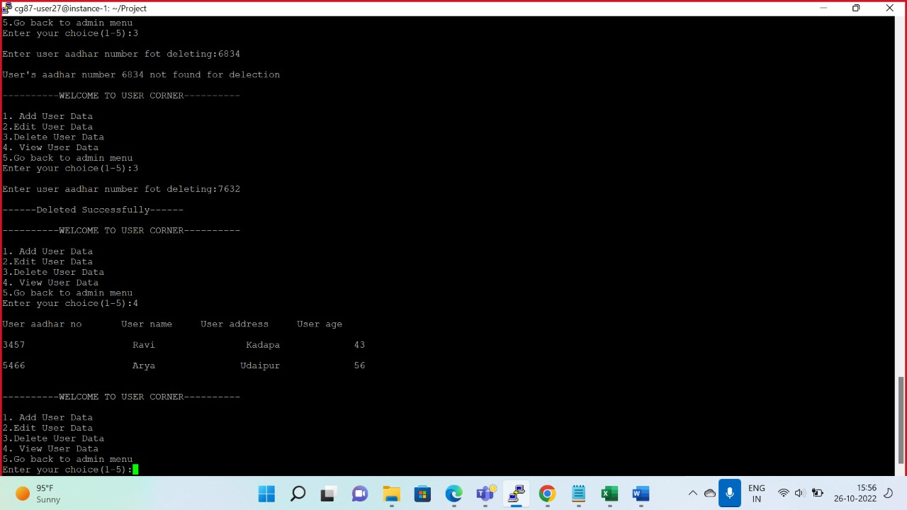

**DRIVERS’S CORNER:**

ADD DRIVER’S DATA

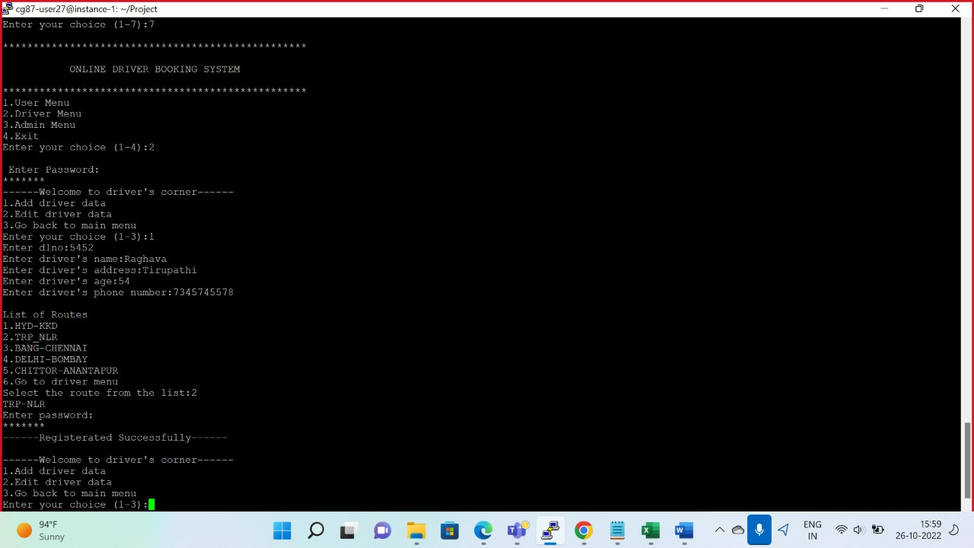

EDIT DRIVER’S DATA

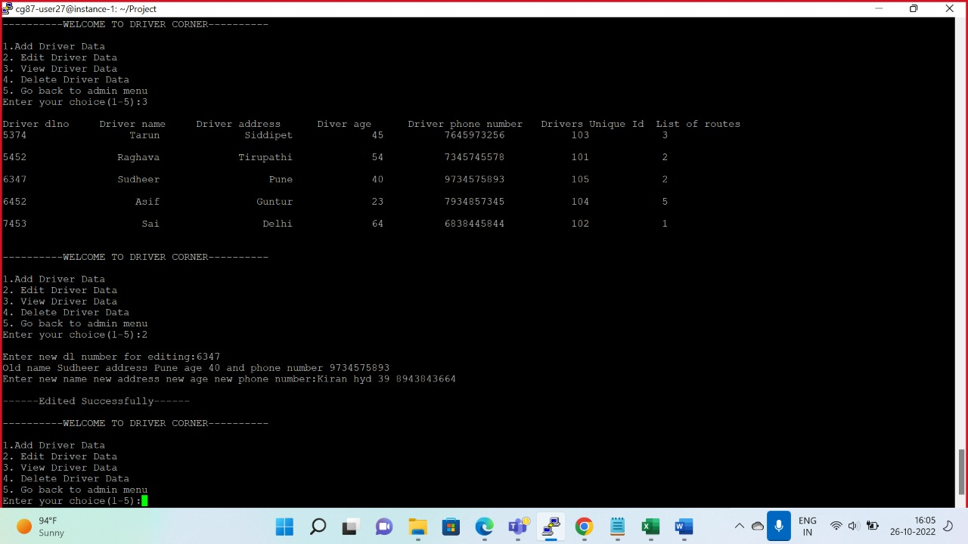

**ADMIN’S CORNER:**

USER MAINTANANCE



DRIVER MAINTAINANCE

EDIT DATA



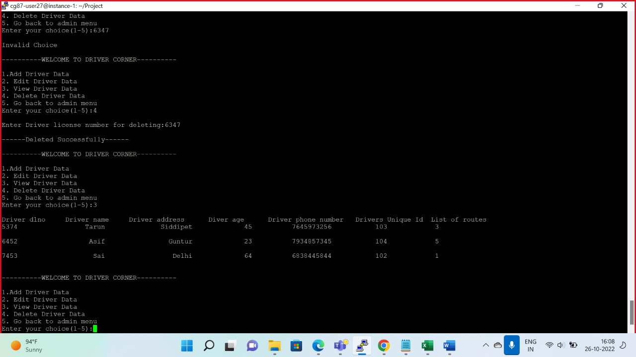

LIST OF REPORTS

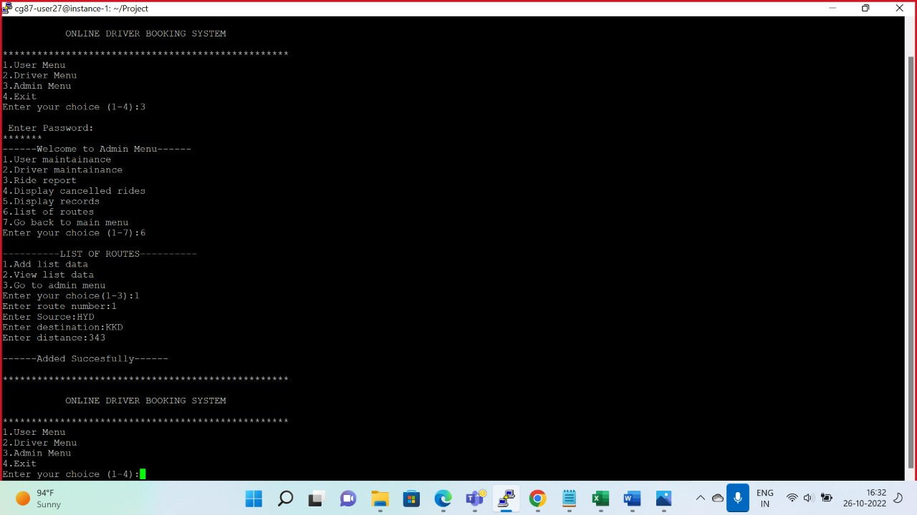

RIDE REPORT